Calculator Free
The Natural Logarithm and Anti-Differentiation

Time: 45 minutes
Total Marks: 45
Your Score: / 45



Question One: [2, 3, 3 = 8 marks] CF

Determine each of the following anti-derivatives, simplifying your answer where possible:

(a)

(b)

(c)

Question Two: [4, 4 = 8 marks] CF

Calculate each of the following definite integrals, simplifying your answers using logarithmic laws.

(a)

(b)

Question Three: [3, 4, 4 = 11 marks] CF

Consider the function

(a) Sketch the function on the axes below.

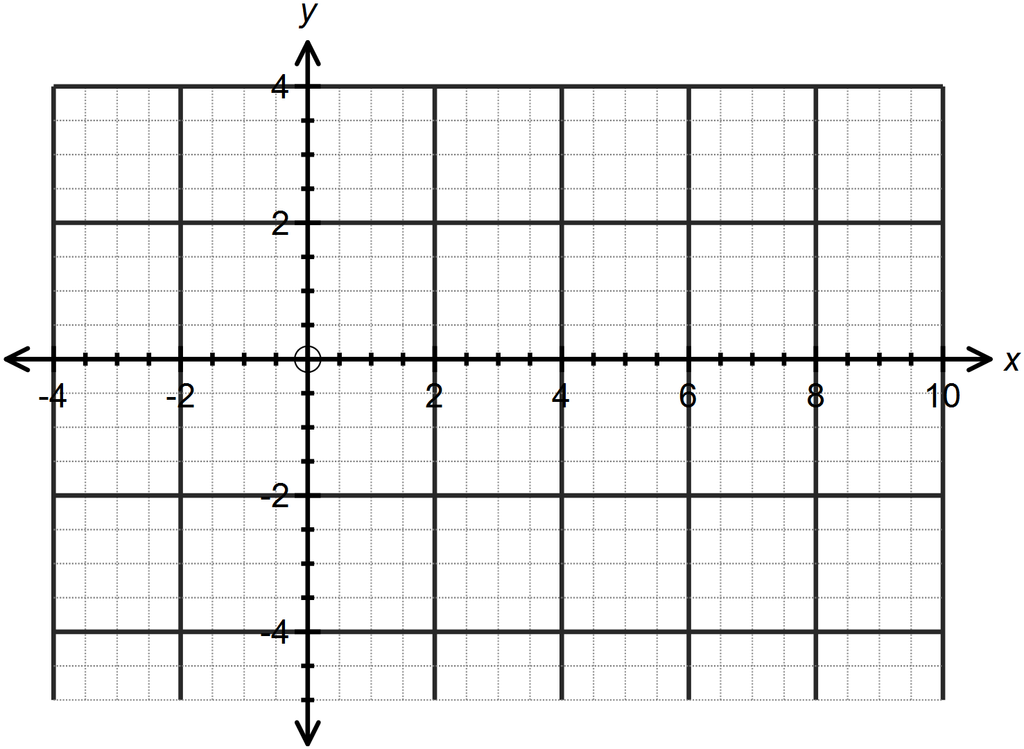

(b) Calculate the area bounded by the function,the x – axis and the lines and . Simplify your answer.

(c) Calculate the area bounded by the function, the y – axis and the lines and .

Question Four: [4 marks] CF

Show that the exponential rule used to calculate compound interest, can be
written as .

Question Five: [3, 1, 1, 2, 2 =9 marks] CF

Newton’s Law of Cooling allows us to monitor the rate at which the difference between the temperature of a body and its surrounds will cool over time.

This can be defined as: where is the difference between the temperature of the body and the surrounding room temperature and t is the time in minutes since the body was introduced to the room.

In order to find a rule modelling in terms of t, we can first separate the variables as follows:
We can then integrate both sides, as follows:
(a) Integrate and equate each side to show that

A pizza is removed from a 200˚C oven and put on the bench in a 25˚C room. After 5 minutes, the temperature of the pizza is 120˚C.

(b) Initially, what is the value of ?

(c) After 5 minutes, what is the value of ?

(d) Hence or otherwise determine the values of k and c.

(e) Hence determine when the pizza has reached room temperature.

Question Six: [3, 2 = 5 marks] CF

Synergy, the provider of electricity in Perth, monitor the maximum consumption of electricity over summer measured against the maximum temperatures.

Graphing the data provides us with the following graph, where C is maximum consumption in megawatts and T is the maximum temperature in degrees Celsius.
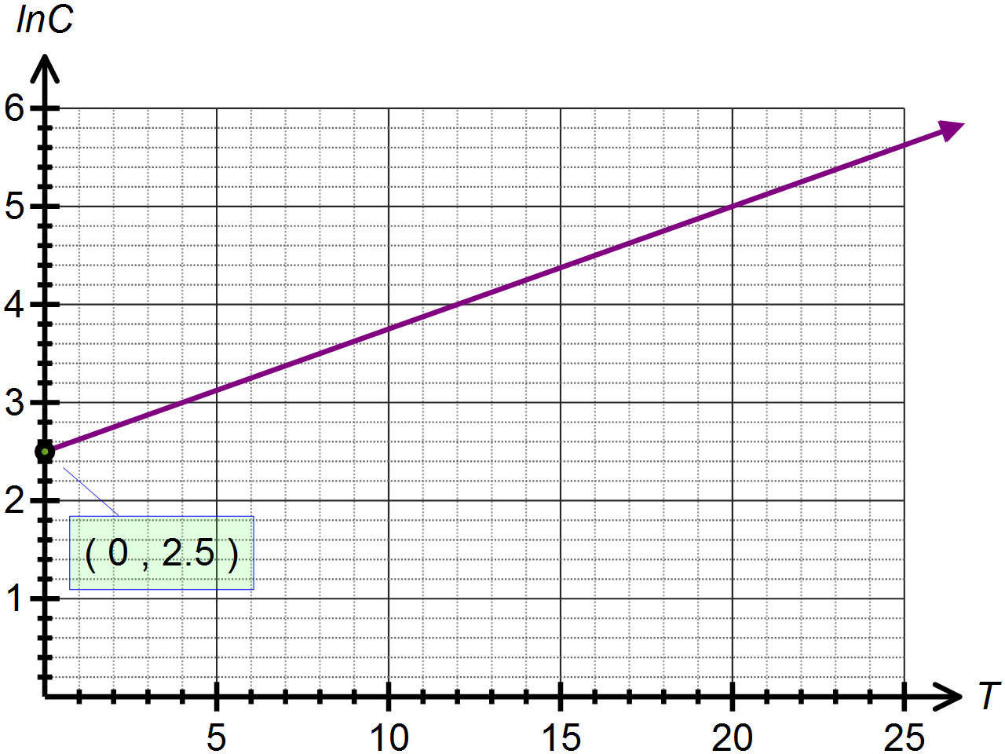

(a) Determine the equation of in terms of .

(b) Use your answer to (a) to determine the exponential function which models the energy consumption based on the maximum temperature recorded.
SOLUTIONS
Calculator Free
The Natural Logarithm and Anti-Differentiation

Time: 45 minutes
Total Marks: 45
Your Score: / 45



Question One: [2, 3, 3 = 8 marks] CF

Determine each of the following anti-derivatives, simplifying your answer where possible:

(a)




(b)




(c)



Question Two: [4, 4 = 8 marks] CF

Calculate each of the following definite integrals, simplifying your answers using logarithmic laws.

(a)






(b)



Question Three: [3, 4, 4 = 11 marks] CF

Consider the function

(a) Sketch the function on the axes below.


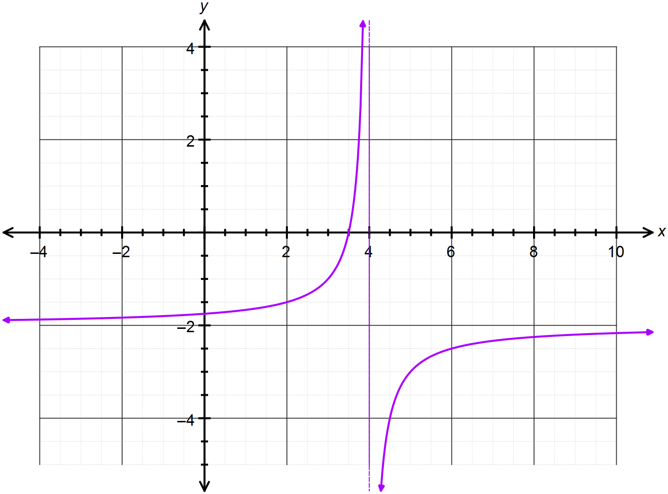





(b) Calculate the area bounded by the function, the x – axis and the lines and . Simplify your answer.





(c) Calculate the area bounded by the function, the y – axis and the lines and .






Question Four: [4 marks] CF

Show that the exponential rule used to calculate compound interest, can be
written as .






Question Five: [3, 1, 1, 2, 2 =9 marks] CF

Newton’s Law of Cooling allows us to monitor the rate at which the difference between the temperature of a body and its surrounds will cool over time.

This can be defined as: where is the difference between the temperature of the body and the surrounding room temperature and t is the time in minutes since the body was introduced to the room.

In order to find a rule modelling in terms of t, we can first separate the variables as follows:
We can then integrate both sides, as follows:
(a) Integrate and equate each side to show that





A pizza is removed from a 200˚C oven and put on the bench in a 25˚C room. After 5 minutes, the temperature of the pizza is 120˚C.

(b) Initially, what is the value of ?



(c) After 5 minutes, what is the value of ?



(d) Hence or otherwise determine the values of k and c.




(e) Hence determine when the pizza has reached room temperature.




Question Six: [3, 2 = 5 marks] CF

Synergy, the provider of electricity in Perth, monitor the maximum consumption of electricity over summer measured against the maximum temperatures.

Graphing the data provides us with the following graph, where C is maximum consumption in megawatts and T is the maximum temperature in degrees Celsius.


(a) Determine the equation of in terms of .





(b) Use your answer to (a) to determine the exponential function which models the energy consumption based on the maximum temperature recorded.




